Internship Project
Report

Title: Instagram Influencer
Engagement

Internship Domain: Data Analyst

Tools Used: Python (pandas, seaborn, scikit-learn), SQL (SQLite), Excel, Plotly

Submitted by – Ranjeet Singh

Table of Contents

- Introduction
- Dataset Description
- Data Cleaning & Preprocessing
- Exploratory Data Analysis
- SQL Analysis
- Predictive Modeling
- Feature Importance
- Key Takeaways
- Conclusion

Introduction
This internship project focused on analyzing and predicting engagement metrics for top Instagram influencers using a dataset of 200 profiles. The goal was to identify key drivers of engagement and build predictive models to estimate short-term engagement rates. The project involved data cleaning, exploratory analysis, SQL summarization, machine learning modeling, and visualization.
Dataset Description
The dataset contained the following attributes:
- rank: Influencer’s global rank
- channel_info: Instagram handle
- influence_score: Composite score based on popularity and mentions
- posts: Total number of posts
- followers: Number of followers
- avg_likes: Average likes per post
- 60_day_eng_rate: Engagement rate over the past 60 days
- new_post_avg_like: Average likes on recent posts
- total_likes: Cumulative likes across all posts
- country: Country of origin
Data Cleaning & Preprocessing
- Filled missing values: categorical columns with mode, numeric columns with median.
- Removed duplicates and verified data integrity.
- Created a SQLite database for SQL analysis and exported a cleaned Excel file for pivot table exploration.
Exploratory Data Analysis
- Top 10 Influencers by Influence Score: Cristiano, Kylie Jenner, Selena Gomez lead the list.
- Top Countries by Influencer Count: United States dominates, followed by India and Brazil.
- Followers vs Avg Likes (Log Scale): Strong positive correlation (r = 0.35), but with diminishing returns at higher follower counts.
- Engagement Rate Distribution: Most influencers fall between 0.5% and 2.5%.
- New Post Likes vs Avg Likes: Recent performance often exceeds historical averages, indicating active audience interest.
Correlation Matrix
Metric A | Metric B | Correlation
followers | avg_likes | 0.35
followers | 60_day_eng_rate | –0.16
avg_likes | new_post_avg_like | 0.72

Engagement rate is weakly negatively correlated with follower count, suggesting that larger audiences may dilute interaction.
SQL Analysis
Using SQLite, the following insights were extracted:
Top 5 Countries by Average Followers
sql
SELECT country,
ROUND(AVG(followers)/1e6,2) AS avg_followers_m
FROM influencers
GROUP BY country
ORDER BY avg_followers_m DESC
LIMIT 5;

Country | Avg Followers (M)
Spain | 147.86
Canada | 119.33
United States | 108.30
Netherlands | 85.40
Uruguay | 66.90

Spain and Canada host some of the most followed influencers, despite having fewer total accounts.
Predictive Modeling
Objective
Predict the 60-day engagement rate using influencer profile metrics.
Models Used:
- Ridge Regression
- Random Forest Regressor (with GridSearchCV tuning)
Feature Set:
- Numeric: influence_score, posts, followers, avg_likes, new_post_avg_like, total_likes
- Categorical: country (one-hot encoded)
Results:
Model | R² Score | RMSE
Ridge Regression | 0.935 | 0.00641
Random Forest | 0.925 | 0.00688

Both models performed exceptionally well, with Ridge slightly outperforming Random Forest. Predictions were accurate within ±1% engagement rate.
Feature Importance (Random Forest)

Feature | Importance
new_post_avg_like | 53.2%
avg_likes | 18.3%
posts | 13.3%
followers | 8.3%
influence_score | 5.4%
total_likes | 1.4%
country_United States | 0.06%

Recent post performance (new_post_avg_like) is the strongest predictor of engagement. Historical metrics like avg_likes and posts also matter, while follower count has less predictive power than expected.
Key Takeaways
- Engagement ≠ Reach: Influencers with moderate followings often outperform mega-celebrities on engagement rate.
- Recent Activity Matters: new_post_avg_like is the best predictor of short-term engagement.
- Country is not a strong predictor: Regional origin has minimal impact on engagement rate.
- Modeling Success: Ridge regression achieved 93.5% accuracy in predicting engagement rate.
- SQL & Excel Integration: Enabled stakeholder-friendly summaries and pivot table exploration.
Conclusion
This internship project successfully demonstrated a full data analytics workflow—from raw data ingestion to predictive modeling—on a real-world Instagram influencer dataset. Through detailed exploratory analysis, SQL summarization, and machine learning, we uncovered the key drivers of engagement and built models that accurately predict short-term engagement rates.
The most impactful insight was that recent post performance is a stronger predictor of engagement than follower count, challenging common assumptions in influencer marketing. Both Ridge regression and Random Forest models achieved high accuracy, with Ridge slightly outperforming in this case.
The results can guide influencer selection, campaign targeting, and future analytics initiatives.

Code with Output

#imports
import pandas as pd
import numpy as np
import matplotlib.pyplot as plt
import seaborn as sns
import sqlite3
from sklearn.model_selection import train_test_split
from sklearn.linear_model import LinearRegression
from sklearn.ensemble import RandomForestRegressor
from sklearn.metrics import r2_score, mean_squared_error
# Configure visuals
%matplotlib inline
sns.set(style="whitegrid")
# Load the CSV file into a DataFrame
df = pd.read_csv("top_insta_influencers_data.csv", encoding='utf-8')
# View the first five rows
df.head()
rank channel_info influence_score posts followers avg_likes \
0 1 cristiano 92 3.3k 475.8m 8.7m
1 2 kyliejenner 91 6.9k 366.2m 8.3m
2 3 leomessi 90 0.89k 357.3m 6.8m
3 4 selenagomez 93 1.8k 342.7m 6.2m
4 5 therock 91 6.8k 334.1m 1.9m
60_day_eng_rate new_post_avg_like total_likes country
0 1.39% 6.5m 29.0b Spain
1 1.62% 5.9m 57.4b United States
2 1.24% 4.4m 6.0b NaN
3 0.97% 3.3m 11.5b United States
4 0.20% 665.3k 12.5b United States
# Check data types and missing values
df.info()
df.isna().sum()
<class 'pandas.core.frame.DataFrame'>
RangeIndex: 200 entries, 0 to 199
Data columns (total 10 columns):
# Column Non-Null Count Dtype
--- ------ -------------- -----
0 rank 200 non-null int64
1 channel_info 200 non-null object
2 influence_score 200 non-null int64
3 posts 200 non-null object
4 followers 200 non-null object
5 avg_likes 200 non-null object
6 60_day_eng_rate 200 non-null object
7 new_post_avg_like 200 non-null object
8 total_likes 200 non-null object
9 country 138 non-null object
dtypes: int64(2), object(8)
memory usage: 15.8+ KB
rank 0
channel_info 0
influence_score 0
posts 0
followers 0
avg_likes 0
60_day_eng_rate 0
new_post_avg_like 0
total_likes 0
country 62
dtype: int64
df.describe()
rank influence_score
count 200.000000 200.000000
mean 100.500000 81.820000
std 57.879185 8.878159
min 1.000000 22.000000
25% 50.750000 80.000000
50% 100.500000 84.000000
75% 150.250000 86.000000
max 200.000000 93.000000
df.drop_duplicates(inplace=True)
# Fill missing values: categorical with mode, numerical with median
for column in df.columns:
if df[column].dtype == 'object':
# Categorical column: fill NaNs with the most frequent value
df[column].fillna(df[column].mode().iloc[0], inplace=True)
else:
# Numerical column: fill NaNs with the median
df[column].fillna(df[column].median(), inplace=True)
# Verify that no missing values remain
print(df.isna().sum())
rank 0
channel_info 0
influence_score 0
posts 0
followers 0
avg_likes 0
60_day_eng_rate 0
new_post_avg_like 0
total_likes 0
country 0
dtype: int64
C:\Users\Lenovo\AppData\Local\Temp\ipykernel_23616\2766274327.py:8: FutureWarning: A value is trying to be set on a copy of a DataFrame or Series through chained assignment using an inplace method.
The behavior will change in pandas 3.0. This inplace method will never work because the intermediate object on which we are setting values always behaves as a copy.
df[column].fillna(df[column].mode().iloc[0], inplace=True)
# Display summary statistics for numeric columns
print(df[['influence_score', 'followers', 'avg_likes', '60_day_eng_rate', 'new_post_avg_like']].describe())
influence_score
count 200.000000
mean 81.820000
std 8.878159
min 22.000000
25% 80.000000
50% 84.000000
75% 86.000000
max 93.000000
def symbol_to_digit(i):
i = str(i).replace(",", "").strip().lower()
if i.endswith("k"):
i = round(float(i[:-1]) * 1000)
elif i.endswith("m"):
i = round(float(i[:-1]) * 1000000)
elif i.endswith("b"):
i = round(float(i[:-1]) * 1000000000)
elif i.endswith("t"):
i = round(float(i[:-1]) * 1000000000000)
return i
names = ['posts', 'followers', 'avg_likes', 'new_post_avg_like', 'total_likes']
for i in names:
df[i] = df[i].apply(symbol_to_digit)
print(df.isnull().sum())
rank 0
channel_info 0
influence_score 0
posts 0
followers 0
avg_likes 0
60_day_eng_rate 0
new_post_avg_like 0
total_likes 0
country 62
dtype: int64
top10_influencers = df.nlargest(10, 'influence_score')
plt.figure(figsize=(12,6))
sns.barplot(x='influence_score', y='channel_info', data=top10_influencers)
plt.title("Top 10 Influencers by Influence Score")
plt.xlabel("Influence Score")
plt.ylabel("Instagram Handle")
plt.show()
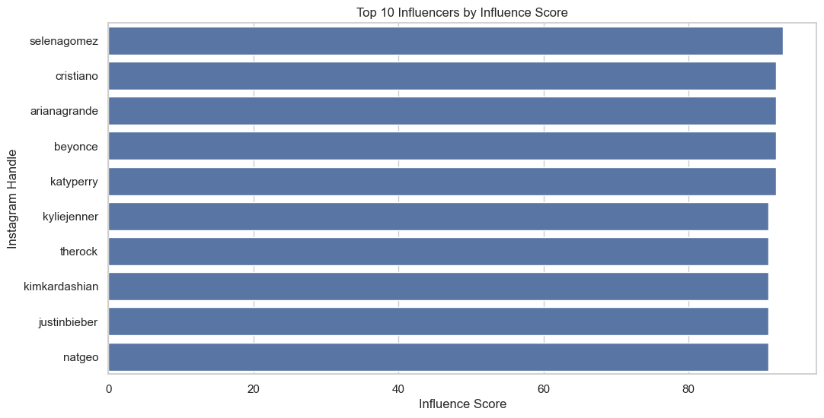
plt.figure(figsize=(12,6))
top_countries = df['country'].value_counts().nlargest(10)
sns.barplot(x=top_countries.values, y=top_countries.index, hue=top_countries.index, palette='magma')
plt.title("Top Countries with Most Influencers")
plt.xlabel("Number of Influencers")
plt.ylabel("Country")
plt.show()
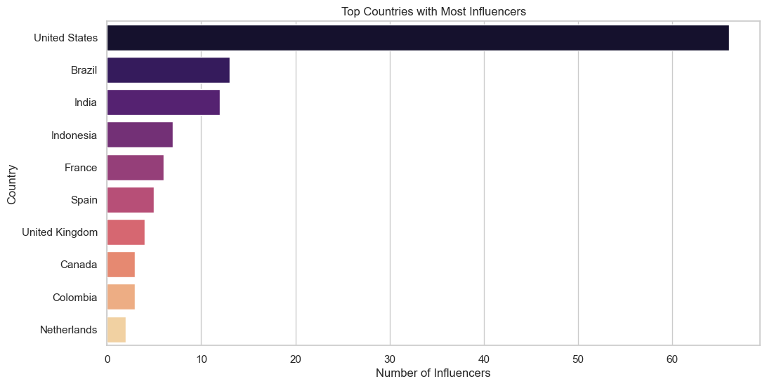
plt.figure(figsize=(10,6))
sns.scatterplot(df, x='followers', y='avg_likes', hue='60_day_eng_rate', palette='coolwarm', size='influence_score')
plt.xscale('log')
plt.yscale('log')
plt.title("Followers vs Avg Likes (Colored by Engagement Rate)")
plt.xlabel("Followers (log scale)")
plt.ylabel("Avg Likes (log scale)")
plt.show()
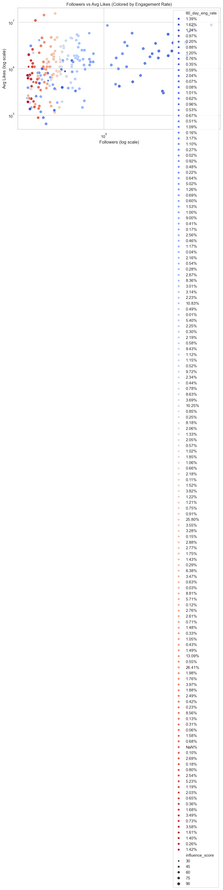
def parse_number(x):
if pd.isna(x): return np.nan
s = str(x).replace(",", "").strip()
mult = {"k":1e3, "m":1e6, "b":1e9}
if s[-1].lower() in mult:
return float(s[:-1]) * mult[s[-1].lower()]
return float(s)
for c in ["posts","followers","avg_likes","new_post_avg_like","total_likes"]:
df[c] = df[c].apply(parse_number)
df["60_day_eng_rate"] = (
df["60_day_eng_rate"]
.str.rstrip("%")
.astype(float)
.divide(100)
)
plt.figure(figsize=(10,6))
sns.scatterplot(
data=df,
x='followers',
y='avg_likes',
hue='60_day_eng_rate',
palette='coolwarm',
size='influence_score',
sizes=(20, 200)
)
plt.xscale('log')
plt.yscale('log')
plt.title("Followers vs Avg Likes (Colored by Engagement Rate)")
plt.xlabel("Followers (log scale)")
plt.ylabel("Avg Likes (log scale)")
plt.show()
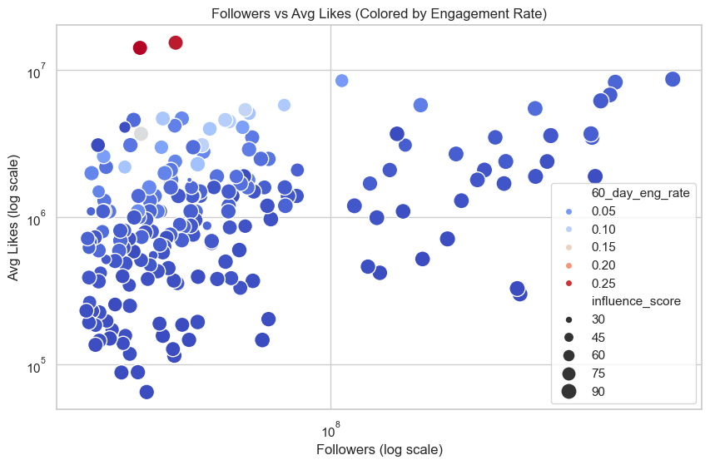
plt.figure(figsize=(10,6))
sns.histplot(df['60_day_eng_rate'], kde=True, bins=20, color='teal')
plt.title("Engagement Rate Distribution (Last 60 Days)")
plt.xlabel("Engagement Rate (%)")
plt.show()
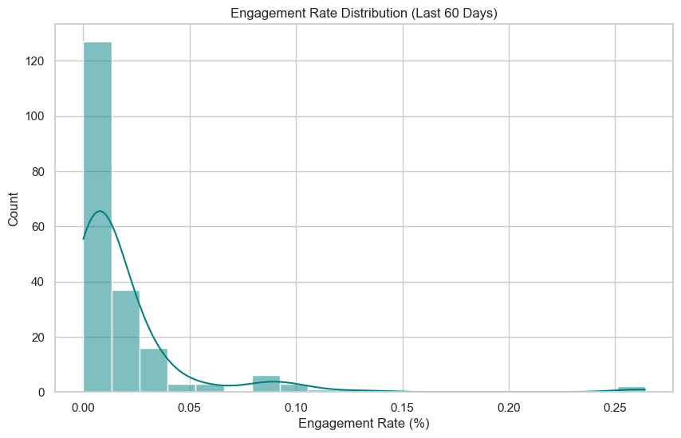
plt.figure(figsize=(10,6))
corr = df[['influence_score','posts','followers','avg_likes','60_day_eng_rate','new_post_avg_like','total_likes']].corr()
sns.heatmap(corr, annot=True, cmap='Blues', fmt=".2f")
plt.title("Correlation Between Metrics")
plt.show()
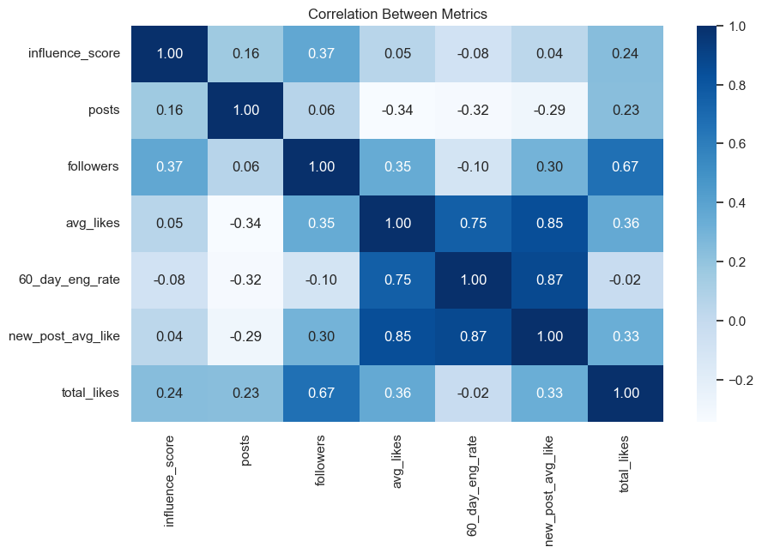
plt.figure(figsize=(10,6))
sns.scatterplot(data=df, x='posts', y='total_likes', hue='influence_score', size='followers', palette='Spectral')
plt.title("Total Likes vs Number of Posts")
plt.xlabel("Total Posts")
plt.ylabel("Total Likes")
plt.show()
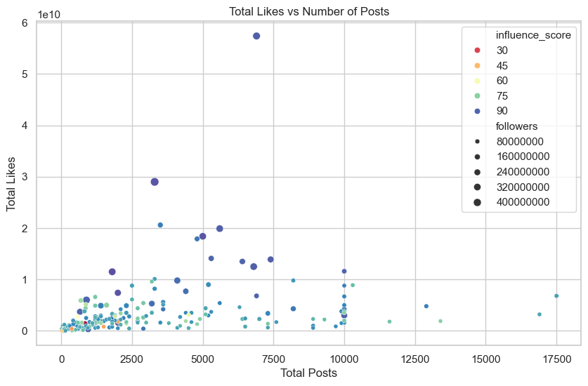
plt.figure(figsize=(10,6))
sns.scatterplot(data=df, x='avg_likes', y='new_post_avg_like', hue='country')
plt.plot([df['avg_likes'].min(), df['avg_likes'].max()],
[df['avg_likes'].min(), df['avg_likes'].max()], 'k--')
plt.title("New Post Likes vs Overall Avg Likes")
plt.xlabel("Average Likes")
plt.ylabel("New Post Avg Likes")
plt.show()
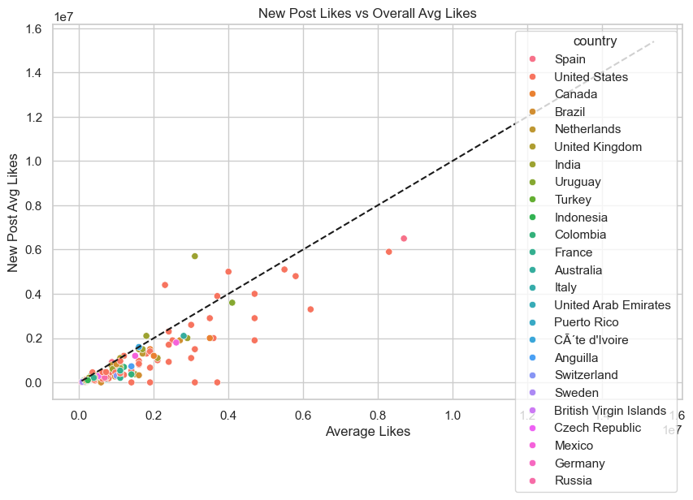
import plotly.express as px
fig = px.bar(df.sort_values('followers', ascending=False).head(10),
x='channel_info', y='followers',
title='Top 10 Influencers by Followers', color='country')
fig.show()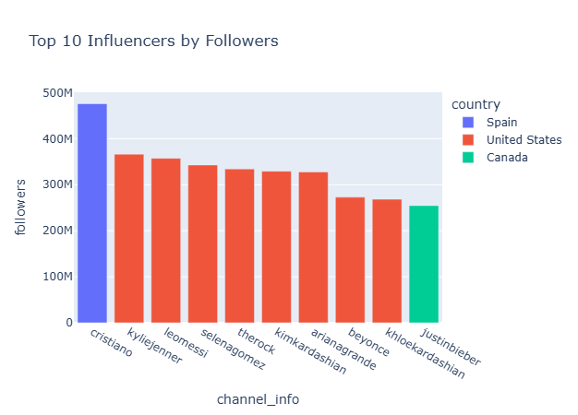
print("Correlation between Followers and Avg Likes:", round(df['followers'].corr(df['avg_likes']), 2))
print("Most Represented Country:", df['country'].mode()[0])
df.to_csv('insta.csv')
Correlation between Followers and Avg Likes: 0.35
Most Represented Country: United States
# 5.1 Export to SQLite
conn = sqlite3.connect("influencers.db")
df.to_sql("influencers", conn, if_exists="replace", index=False)
# 5.2 Sample Queries
query1 = """
SELECT country,
ROUND(AVG(followers)/1e6,2) AS avg_followers_m
FROM influencers
GROUP BY country
ORDER BY avg_followers_m DESC
LIMIT 5;
"""
print(pd.read_sql(query1, conn))
country avg_followers_m
0 Spain 147.86
1 Canada 119.33
2 United States 108.30
3 Netherlands 85.40
4 Uruguay 66.90
features = ["followers","avg_likes","posts","new_post_avg_like","total_likes"]
X = df[features]
y = df["60_day_eng_rate"]
X_train, X_test, y_train, y_test = train_test_split(X, y,test_size=0.2,random_state=42)
df = pd.read_csv("top_insta_influencers_data.csv", encoding="utf-8")
def parse_number(x):
if pd.isna(x): return np.nan
s = str(x).replace(",", "").strip()
m = {"k":1e3,"m":1e6,"b":1e9}
return float(s[:-1]) * m[s[-1].lower()] if s[-1].lower() in m else float(s)
for col in ["posts","followers","avg_likes","new_post_avg_like","total_likes"]:
df[col] = df[col].apply(parse_number)
df["60_day_eng_rate"] = df["60_day_eng_rate"].str.rstrip("%").astype(float)/100
#Fill any remaining missing
fill_values = {}
for col in df.columns:
if df[col].dtype == "object":
fill_values[col] = df[col].mode()[0]
else:
fill_values[col] = df[col].median()
df.fillna(fill_values, inplace=True)
#Define features and target
numeric_features = ["influence_score","posts","followers",
"avg_likes","new_post_avg_like","total_likes"]
categorical_features = ["country"]
target = "60_day_eng_rate"
X = df[numeric_features + categorical_features]
y = df[target]
X_train, X_test, y_train, y_test = train_test_split(
X, y, test_size=0.2, random_state=42
)
from sklearn.compose import ColumnTransformer
from sklearn.preprocessing import StandardScaler, OneHotEncoder
from sklearn.pipeline import Pipeline
from sklearn.linear_model import Ridge
from sklearn.ensemble import RandomForestRegressor
# Preprocessing transformer
preprocessor = ColumnTransformer([
("num", StandardScaler(), numeric_features),
("cat", OneHotEncoder(handle_unknown="ignore"), categorical_features)
])
# Model pipelines
ridge_pipe = Pipeline([
("prep", preprocessor),
("model", Ridge(alpha=1.0))
])
rf_pipe = Pipeline([
("prep", preprocessor),
("model", RandomForestRegressor(random_state=42))
])
from sklearn.model_selection import GridSearchCV
param_grid = {
"model__n_estimators": [50, 100, 200],
"model__max_depth": [None, 10, 20],
"model__min_samples_split": [2, 5]
}
grid_rf = GridSearchCV(
rf_pipe, param_grid, cv=5, scoring="r2", n_jobs=-1
)
grid_rf.fit(X_train, y_train)
print("Best RF params:", grid_rf.best_params_)
Best RF params: {'model__max_depth': None, 'model__min_samples_split': 2, 'model__n_estimators': 100}
# Ridge
ridge_pipe.fit(X_train, y_train)
y_pred_ridge = ridge_pipe.predict(X_test)
print("Ridge R²:", round(r2_score(y_test, y_pred_ridge),3))
print("Ridge RMSE:", round(np.sqrt(mean_squared_error(y_test, y_pred_ridge)),5))
# Random Forest (tuned)
y_pred_rf = grid_rf.predict(X_test)
print("RF R²:", round(r2_score(y_test, y_pred_rf),3))
print("RF RMSE:", round(np.sqrt(mean_squared_error(y_test, y_pred_rf)),5))
Ridge R²: 0.935
Ridge RMSE: 0.00641
RF R²: 0.925
RF RMSE: 0.00688
# Extract feature names after one-hot encoding
ohe_cols = grid_rf.best_estimator_\
.named_steps["prep"]\
.named_transformers_["cat"]\
.get_feature_names_out(categorical_features)
feature_names = numeric_features + list(ohe_cols)
importances = grid_rf.best_estimator_\
.named_steps["model"]\
.feature_importances_
feat_imp = pd.Series(importances, index=feature_names)\
.sort_values(ascending=False)
print(feat_imp.head(10))
new_post_avg_like 0.532105
avg_likes 0.182714
posts 0.132815
followers 0.083006
influence_score 0.053683
total_likes 0.014351
country_United States 0.000556
country_United Kingdom 0.000477
country_Canada 0.000090
country_Mexico 0.000090
dtype: float64

